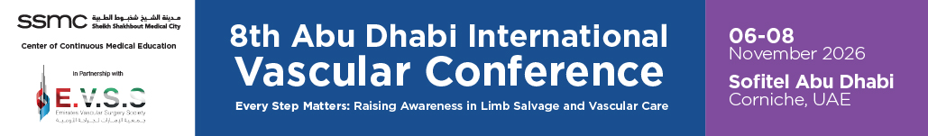ABSTRACT GUIDELINES & FORM

The Scientific Committee cordially invites you to submit abstracts for the prestigious 8th Abu Dhabi International Vascular Conference, taking place from 6–8 November 2026 at Sofitel Abu Dhabi Corniche, Abu Dhabi, UAE.
EXCEPTIONAL OPPORTUNITIES AWAIT
MAIN SESSION OPPORTUNITY:
The top three outstanding poster presentations will be selected for an exclusive opportunity to present their work during the conference's main scientific session.
RECOGNITION AND PRIZES:
Outstanding contributions will be recognized on Day 2 of the conference.
We eagerly anticipate receiving your innovative and impactful research contributions.

DEADLINE OF SUBMISSION: 10 OCTOBER 2026
NOTIFICATION OF ACCEPTED ABSTRACTS: 15 OCTOBER 2026

ABSTRACT TOPICS

GENERAL SCOPE:

☐ Aortic disease
☐ Diabetic foot disease
☐ Cerebrovascular disease
☐ Peripheral vascular disease
☐ Venous Disease
☐ Vascular Access
☐ Vascular Malformations
☐ Thrombosis and Coagulopathy
☐ Vascular trauma
☐ Thoracic Outlet Syndrome
☐ Vascular Training
☐ Vascular Imaging
☐ Vascular Rehabilitation
☐ Trauma
☐ Vascular Surgery
☐ Others

AUTHOR & ABSTRACT INFORMATION

- A maximum of 2 abstracts can be submitted.
- For abstracts with multiple authors, you need to agree on one person that will be presenting the abstract in the conference
- The abstracts must:
  - provide enough information for reviewers to assess the topic's nature and significance, the suitability of the investigative technique, the nature of the results, and the conclusions.
  - summarize the work's substantive outcomes rather than simply listing subjects to be explored.
  - be original scientific data gathered by the author(s) must be included in the abstract. All reports must be based on previously completed work. No "in progress" studies will be allowed.
  - include enough information for reviewers to determine the nature and significance of the topic, the sufficiency of the investigation technique, the nature of the results, and the conclusions, according to the criteria
- The primary author/first author/presenting author will receive:
  - Complimentary registration for all days of the conference and
  - a certificate of attendance and appreciation for your presentation
- The presenter must NOT utilize the session to promote services, products, or other entities that are commercial in nature.
- Travel/accommodation expenses will not be provided

PRESENTER INFORMATION

This area is to be filled out by the details of the presenting author.

COMPLETE NAME | Click or tap here to enter text.
DESIGNATION / PROFESSION | Click or tap here to enter text.
INSTITUTION / FACILITY | Click or tap here to enter text.
EMAIL ADDRESS | Click or tap here to enter text.
[ALTERNATE EMAIL ADDRESS] | Click or tap here to enter text.
MOBILE NUMBER | Click or tap here to enter text.
[WHATSAPP NUMBER] | Click or tap here to enter text.
BRIEF BIOGRAPHY (150 words) | Click or tap here to enter text.
NAMES OF CO-AUTHORS + DESIGNATION & AFFILIATION + EMAIL ADDRESS + CONTACT NO.
(Please provide a maximum of 5 names as co-authors)
Click or tap here to enter text. | Click or tap here to enter text. | Click or tap here to enter text.
Click or tap here to enter text. | Click or tap here to enter text.

ATTENDANCE MODE | ☐LIVE IN-PERSON

**PRESENTATION MODE | ☐ORAL | ☐ POSTER

**CATEGORY | ☐ CLINICAL RESEARCH | ☐ CASE REPORT | ☐ EDUCATIONAL / INFORMATIONAL

**The scientific committee will make the final decision on accepting submissions, assigning the presentation mode and/or category. Time allocation is also dynamic and may change on committee’s discretion.

ABSTRACT TITLE | Click or tap here to enter text.
ABSTRACT CONTENT (400 words maximum)
- Introduction / Background
- Objectives
- Methods
- Results
- Discussion
- Conclusion(s)
- References

Is this abstract published or has it been presented at any international conferences? | ☐Yes ☐ No
Has this abstract won any awards? | ☐Yes ☐ No
*Is this abstract complete?  (Incomplete submissions will not be reviewed) | ☐Yes ☐ No

For accepted abstracts, please acquire permission from your department, Chief, or Academic department to attend the conference.

DEADLINE OF SUBMISSION: 10 OCTOBER 2026
NOTIFICATION OF ACCEPTED ABSTRACTS: 15 OCTOBER 2026

